# Steps to cloning SD card for raspberry pi

1. Download Win32 Disk Imager ([source](https://www.google.com/url?sa=t&rct=j&q=&esrc=s&source=web&cd=&cad=rja&uact=8&ved=2ahUKEwj8nbiumqiFAxXE3TgGHSywBogQFnoECAYQAQ&url=https%3A%2F%2Fsourceforge.net%2Fprojects%2Fwin32diskimager%2F&usg=AOvVaw1SNdrXwADj0DUttQ_zrJzF&opi=89978449))([video guide](https://youtu.be/xSxNJSkSgpk?si=yELswUdh3Zivm_2T))
2. Install the application (next everything and install)

1. After opening the app it should pop up this window.
2. Click on the image file to select where you want to store the image file, just key in the name of the file and click open.
3. Next select the device, open this pc in your folder to see your sd card.

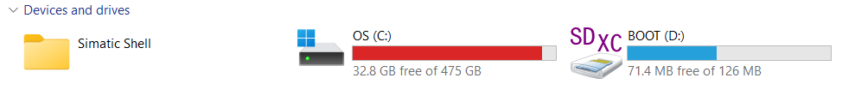

1. Proceed to select your device depending on your sd card

1. After it is selected you will be able to click the read button which will take quite some time to read the SD card and clone the format and information on it onto your computer.
2. Once it is done you can switch to the SD card you want to store the information into and check the device it matches the SD card inserted.
3. click “write” to upload the information into the SD card which will also take some time.
4. After that it is done and can be inserted into other raspberry pi to use.